1.Check if the number 12 is in the array

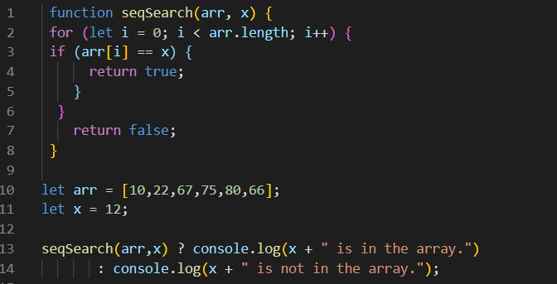

Output



2.Sort array with bubble sort

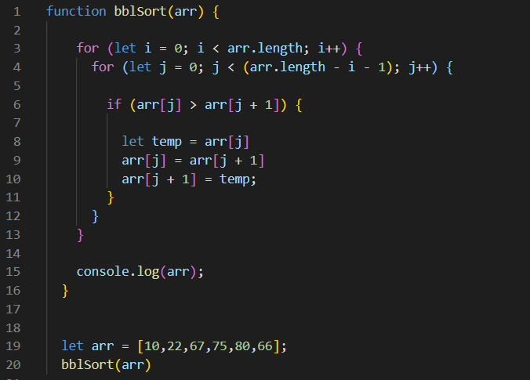

Output



3.Sort array with selection sort

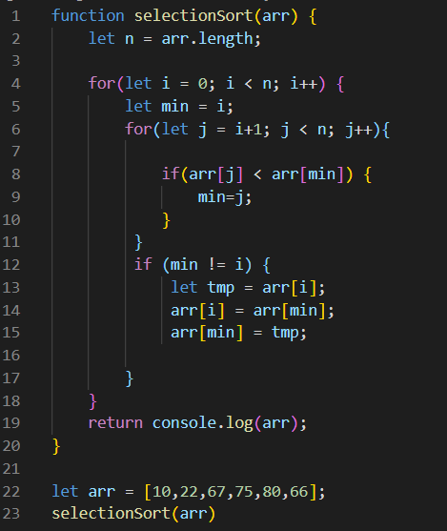

Output



4.Sort array with insertion sort

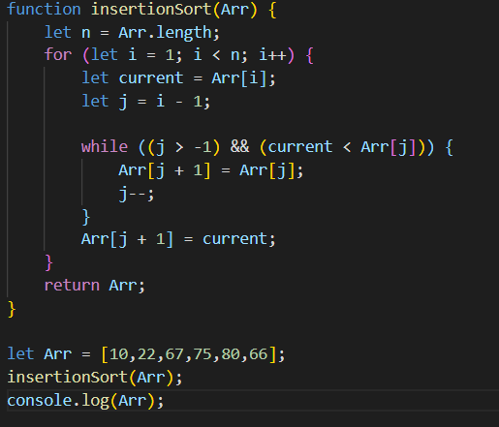

Output

